MAV/MGSE Primary Mathematics Conference
Friday 10th June 2022 Session B2, 10.50-11.50am Room Q416

Lockdown Treasures: e-resources for extending thinking in the primary classroom
Roger Wander, MGSE

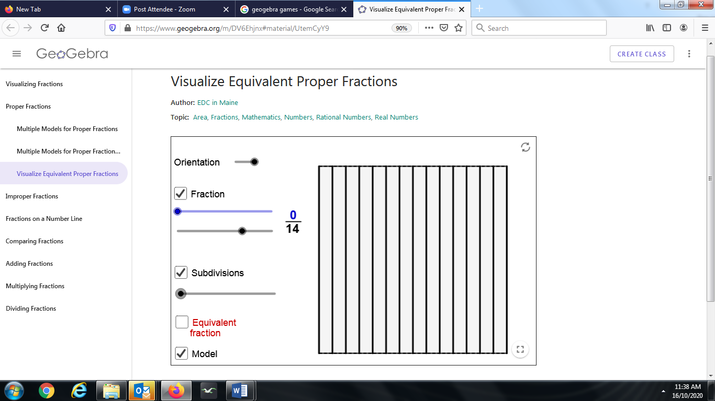 | Equivalent fractions; sliders determine numerator and denominator from 0-20; horizontal subdivisions; good for equal-sized partitions  https://www.geogebra.org/m/DV6Ehjnx#material/UtemCyY9
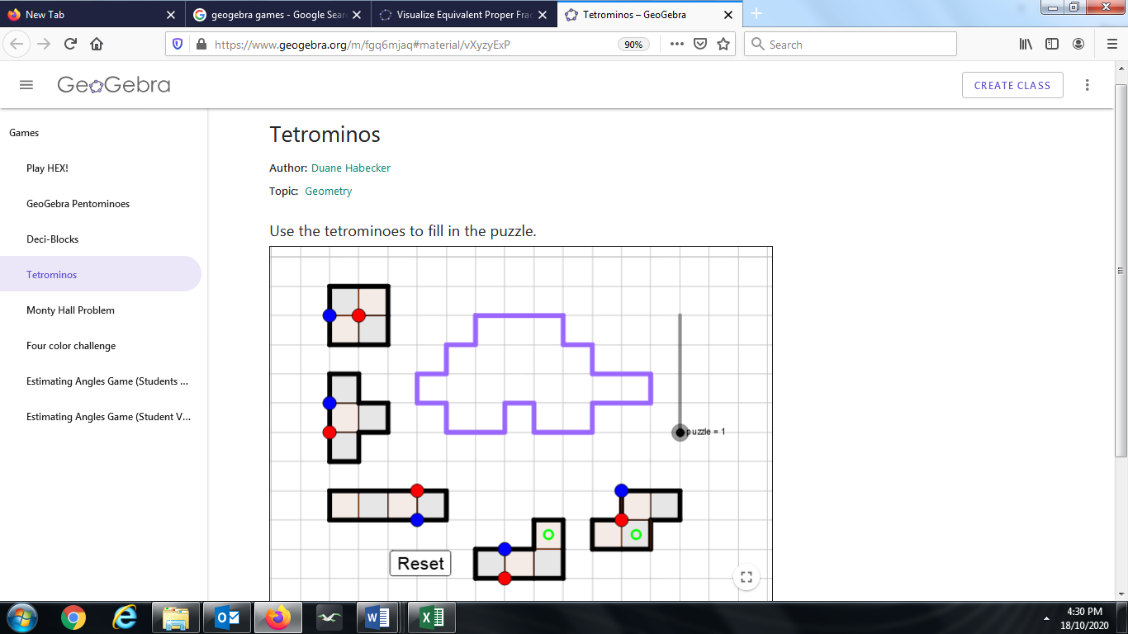 | Tetrominos: five 4-square pieces fit into a 20-square bordered irregular shape; pieces can be translated (blue dot), rotated (red dot) or reflected (green annulus); five different bordered shapes. Promotes language of transformations, spatial relationships.  https://www.geogebra.org/m/fgq6mjaq#material/vXyzyExP
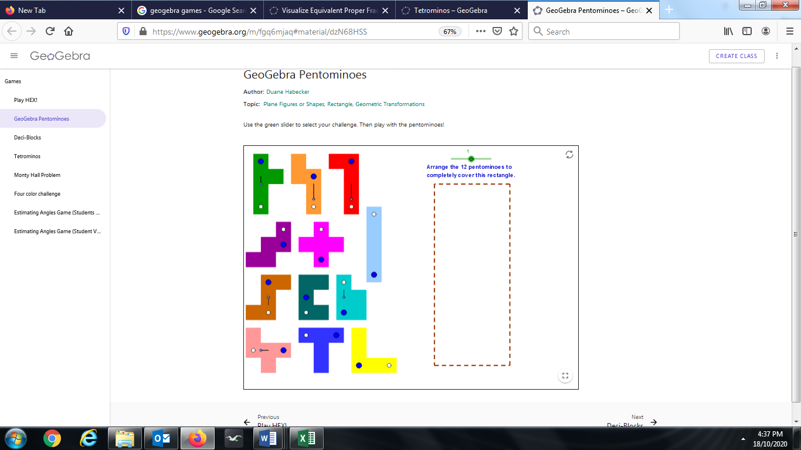 | Pentominos: As with Tetrominos, but twelve 5-square pieces fit into a 60-square bordered rectangular shape; transformations as with Tertrominos; Two different possible rectangular bordered shapes. Promotes language of transformations, spatial relationships.  https://www.geogebra.org/m/fgq6mjaq#material/dzN68HSS
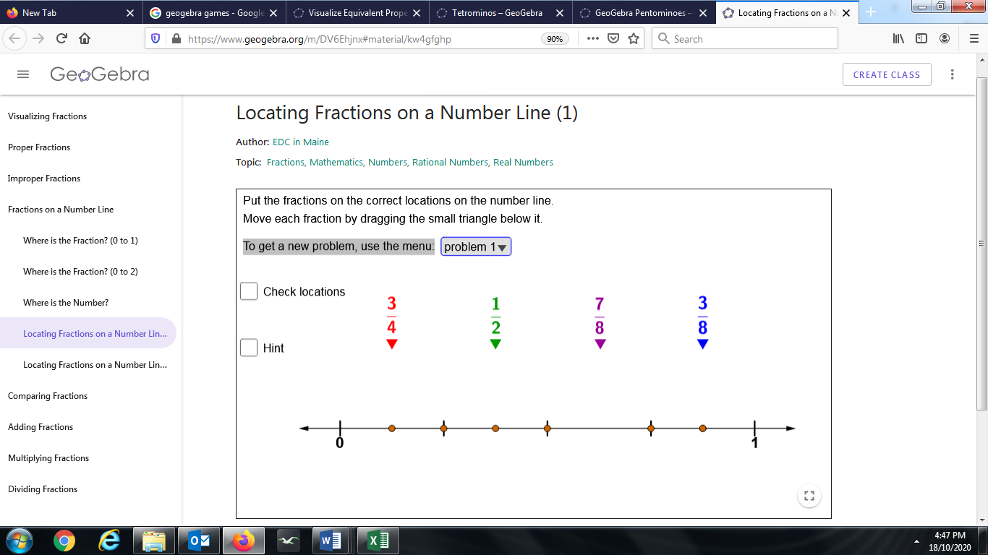 | Locating Fractions on a Number Line:  Drag each of 4 fractions to one of 6 possible locations between 0 and 1, or 0 and 2. Six different problems. Hint can be used without giving away full solution.  https://www.geogebra.org/m/DV6Ehjnx#material/kw4gfghp
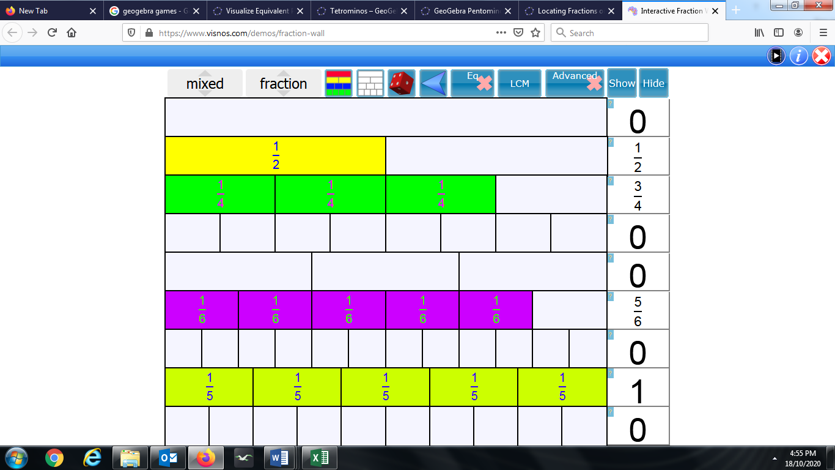 | Fraction Wall: Interactive visualisation of the fraction wall with unit fractions, allowing comparisons of non-unit fractions and visualising equivalence. Controls allow for additional rows to be placed in the wall. Whole number and fractional numbers’ appearance can be toggled on or off. Sliders can be used to increase or decrease the number of subdivisions within a row.  https://www.visnos.com/demos/fraction-wall
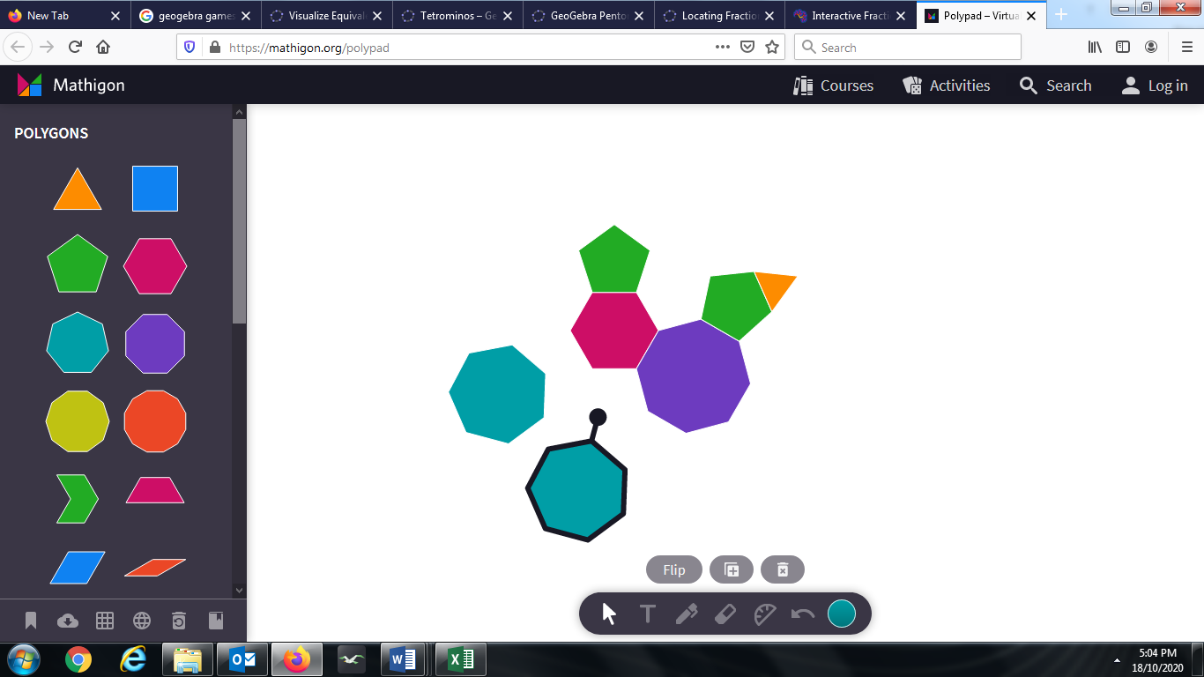 | Polypad (from the Mathigon suite): Regular convex n-gons (n=3 to 10) plus other polygons; drag or click pieces onto Polypad area; use “handle” to rotate a piece around its centre; colours can be altered; pen tool for grouping, text tool for personalising or annotating, eraser tool; protractor tool.  https://mathigon.org/polypad
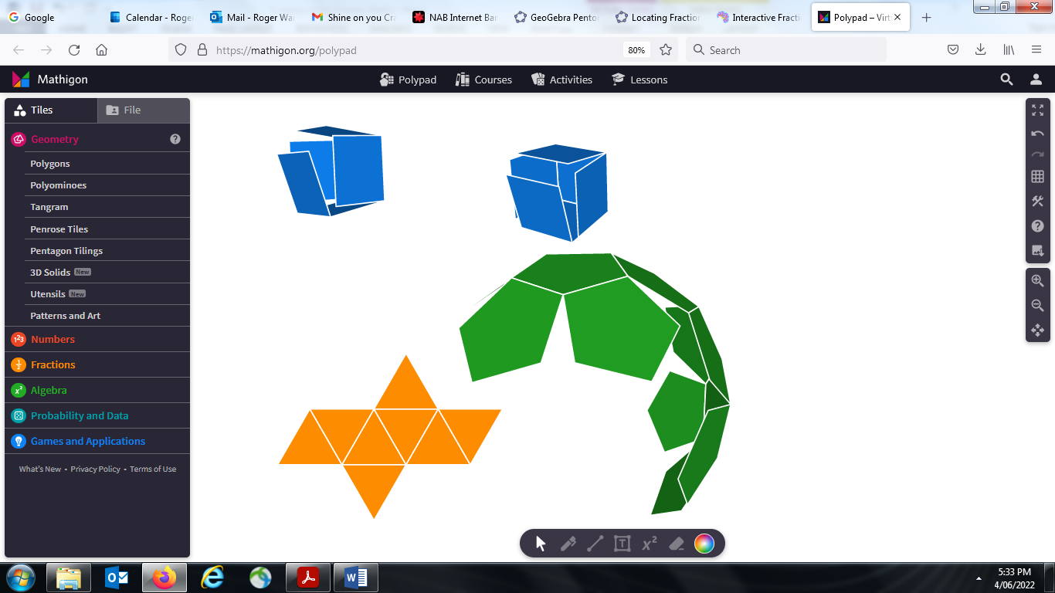 | Also within the Polypad suite are these (scroll down from Polygons, above):  Number tiles (like MAB)  Number bars (as per Cuisinaire rods)  Fraction bars (as per Fraction Wall)  Fraction circles (circular sectors, “pizza slices”)  Algebra tiles (building linear and quadratic expressions)  Tangram  Pentominoes  Tetrominos  Penrose Tiles  3D Solids (great for visualising nets becoming 3D shapes and vice-versa)
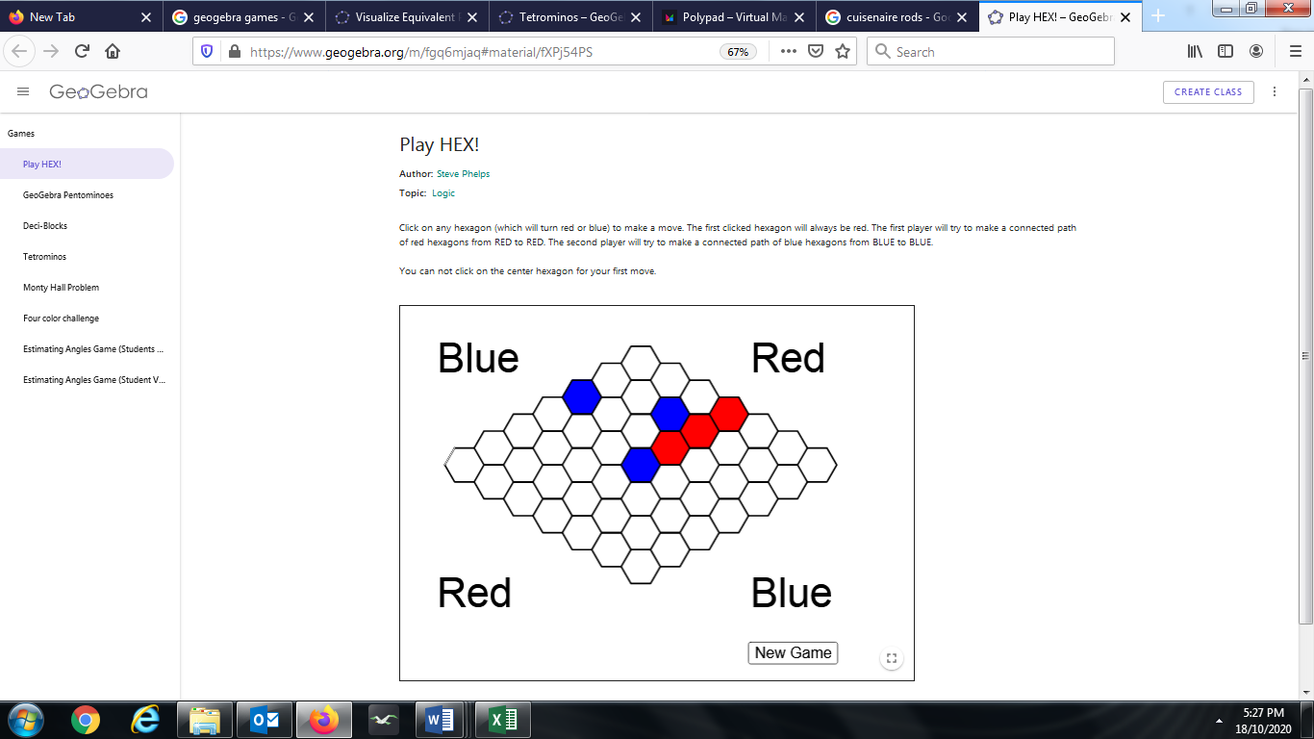 | Hex – logic strategy game  Red always starts; can’t start at centre; clicking on an already coloured-in hexagon will toggle its colour (red to blue or blue to red) but can’t erase it.  https://www.geogebra.org/m/fgq6mjaq#material/fXPj54PS
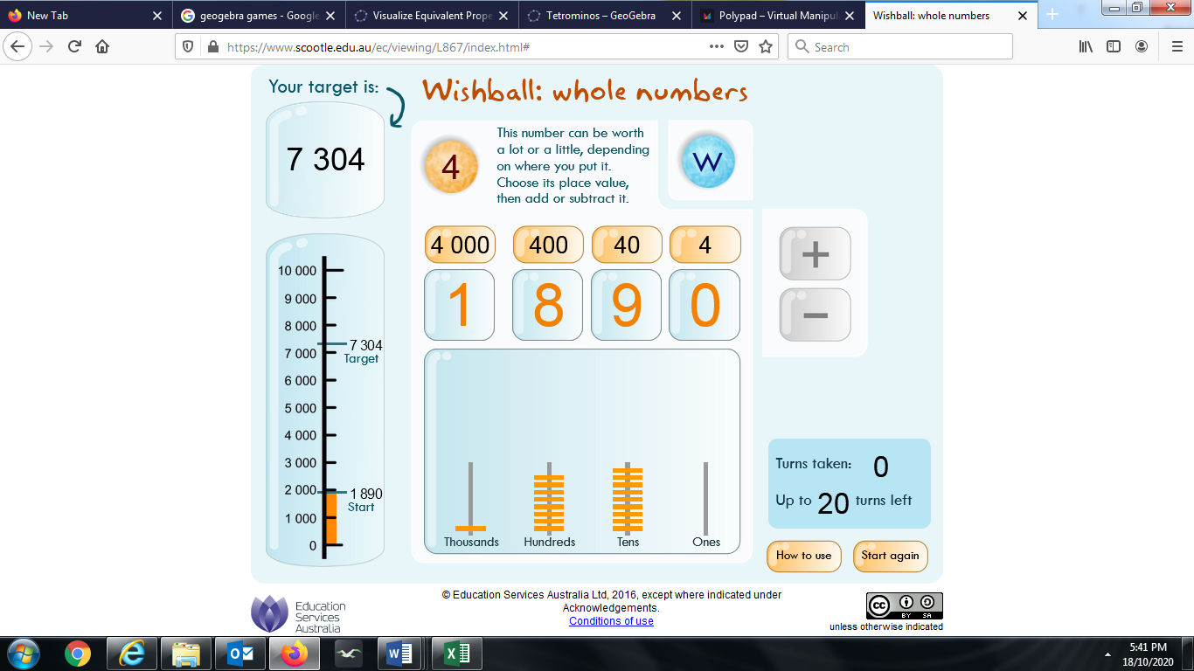 | Wishball (thousands): Strategy and chance with visualisation of the meaning of place value, as well as implications for hundreds converting to tens, etc. In the example shown, the starting number 1890 has to be increased to the target 7304. The spinner (random) has selected 4, so the player needs to decide if 4, 40, 400 or 4000 will be (in this case) added. Orange bars on a spindle increase or decrease as the game goes on – when “borrowing” is required, the breakup into smaller component units is visualised (very fast, however). Goal is to minimise the number of moves required. When a player is 1 step away from the target, the Wishball is selected (as a last move) and the number is chosen – a wrong choice, and the goal is not achieved. There are several decimal versions available as well. Adobe Flash driver required.  https://www.scootle.edu.au/ec/viewing/L867/index.html#
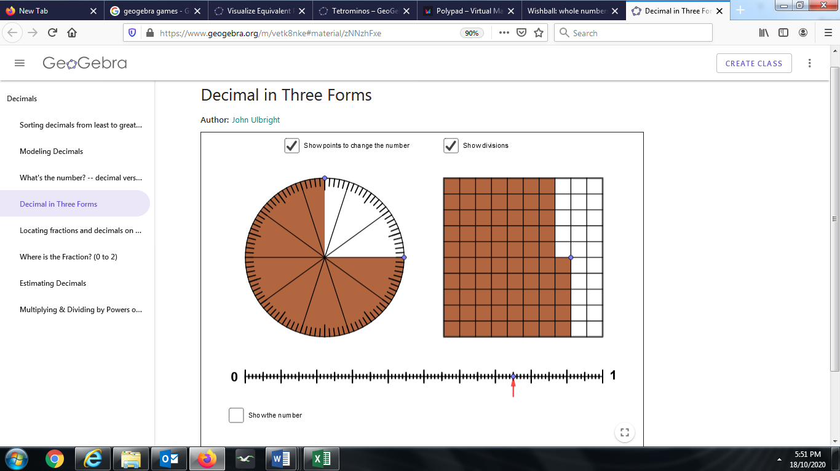 | Decimals in three forms: Circular, rectangular and linear scales all linked by adjusting one of the activating buttons. Displays can toggle appearance of scales and numerical representations (fraction, decimal, percentage). All based on the number 100.  https://www.geogebra.org/m/vetk8nke#material/zNNzhFxe
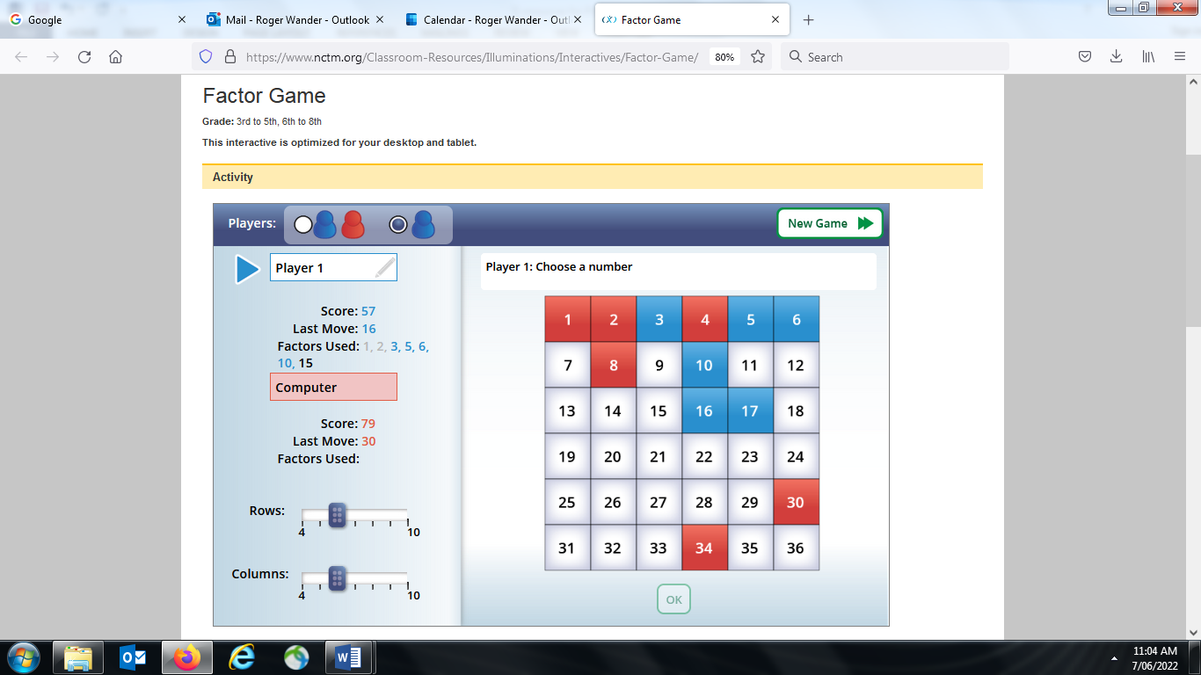 | Factor game (from NCTM); can play against the computer, or against a partner. Adjustable grid allows for differentiation.  https://www.nctm.org/Classroom-Resources/Illuminations/Interactives/Factor-Game/
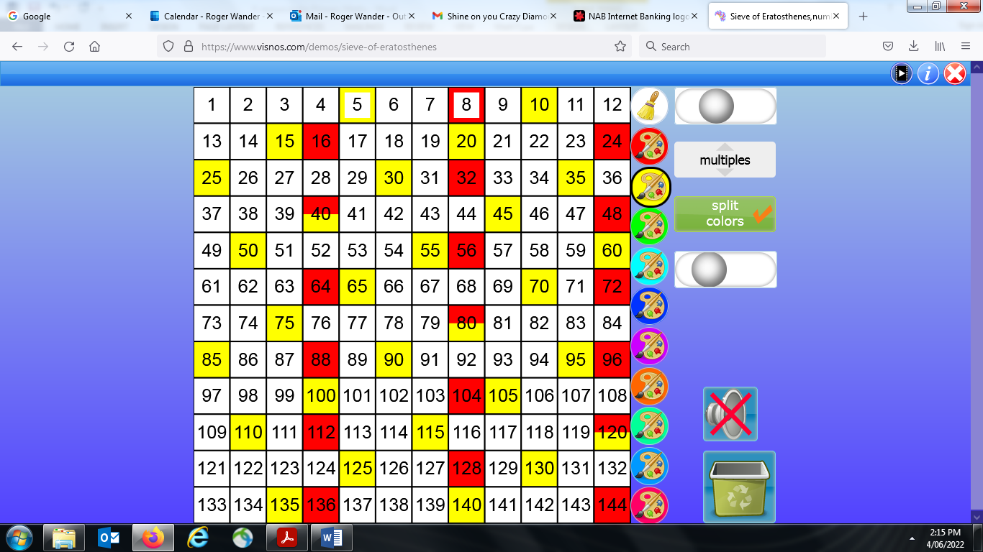 | Sieve of Eratosthanes  Locates prime numbers by highlighting multiples of known primes with multi-coloured, user-driven searches on square number grids from 2×2 to 30×30. Visual patterns of multiples, with variable-speed autofill or manual manipulation. Prime factors of composite numbers can be inferred. Perfect squares (square numbers) and other number categories form interesting visual patterns. Fractional areas (ie, what fraction of the grid is coloured in?) allow for estimation and strategic problem-solving.  https://www.visnos.com/demos/sieve-of-eratosthenes
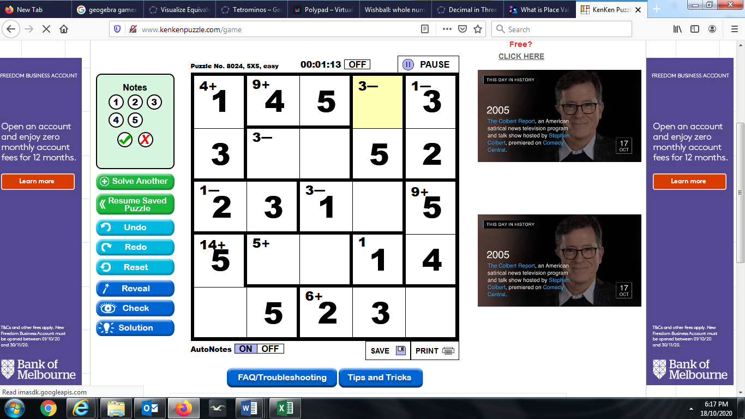 | Ken-Ken, a type of Killer Sudoku where calculations are used to decide which digit goes where. Strategy, logic and arithmetic – plus the ability to bring many facts into play simultaneously. Dimensions 4 by 4 up to 9 by 9. Example shown is a partially completed 5 by 5; the yellow square must be a 2 as that’s the only number missing in the top row, AND because it is the only number within that black-outlined “cage” from 1 to 5 which combined with 5 using subtraction to give 3. Timer keeps the pressure on; puzzles start out completely blank; selecting of dimensions, operation/s involved and degree of difficulty allows for various abilities.  http://www.kenkenpuzzle.com/play_now
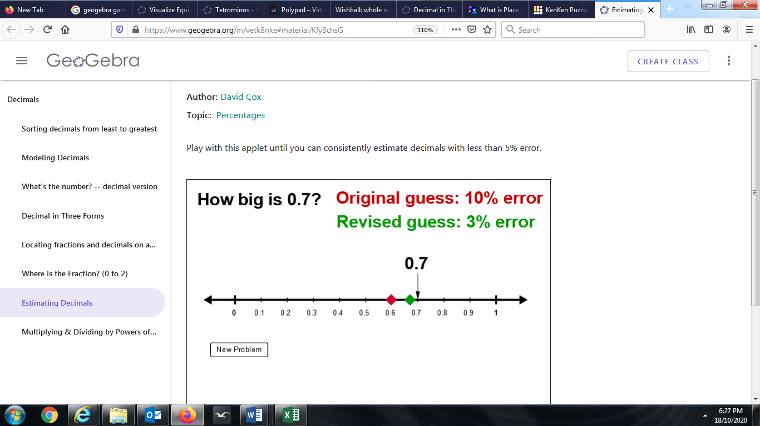 | Estimating decimals – slide the red cursor to an initial “best” position; click “next” and the scale appears and you then move the green cursor to a “better” position. Click on Check Answer and the accuracy of the first and second estimates are shown.  https://www.geogebra.org/m/vetk8nke#material/Kfy3chsG
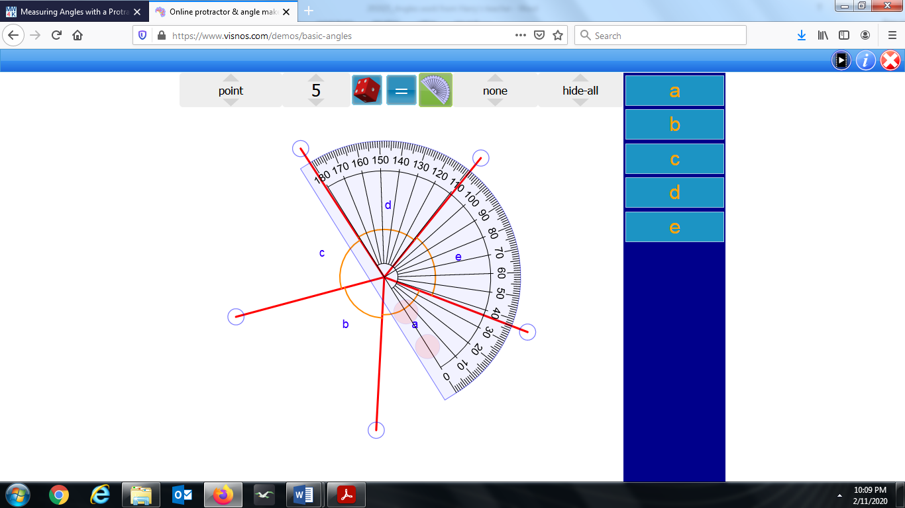 | Basic angles - Excellent moving (rotating) protractor measuring angles; can toggle and hide measurements, angles from a central point, comp/sup, etc. Includes a link (found in the information tab) to an application involving the hands on an analog clock.  https://www.visnos.com/demos/basic-angles
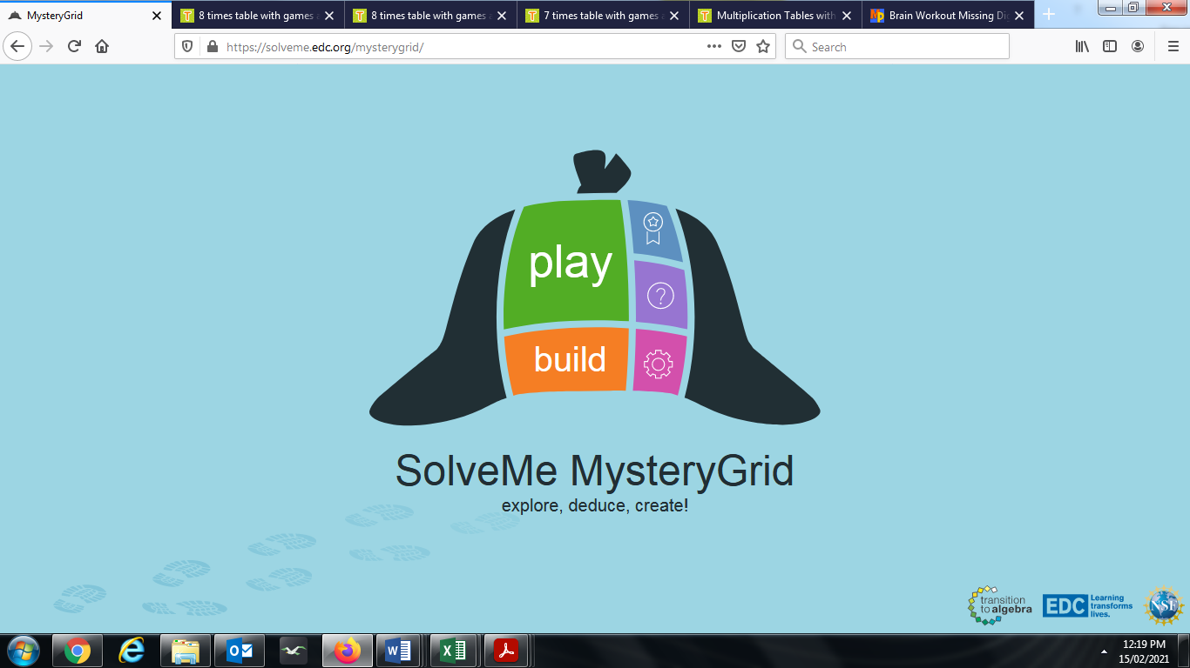 | Mystery grid – a type of Ken-Ken; 200 different puzzles, from 4 by 4 to 6 by 6; relational clues > or < and calculation clues; really good  https://solveme.edc.org/mysterygrid/
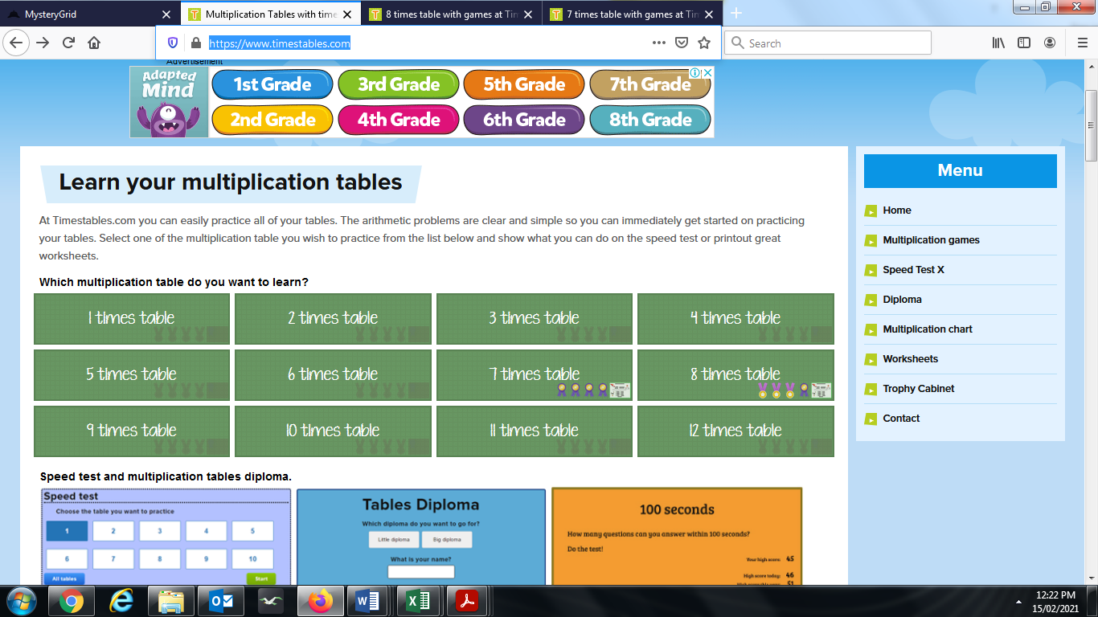 | Multiplication (“times”) tables – good drills working up to a certificate on a 24-question timed test; really good for competitive students working on fast recall of facts  https://www.timestables.com/
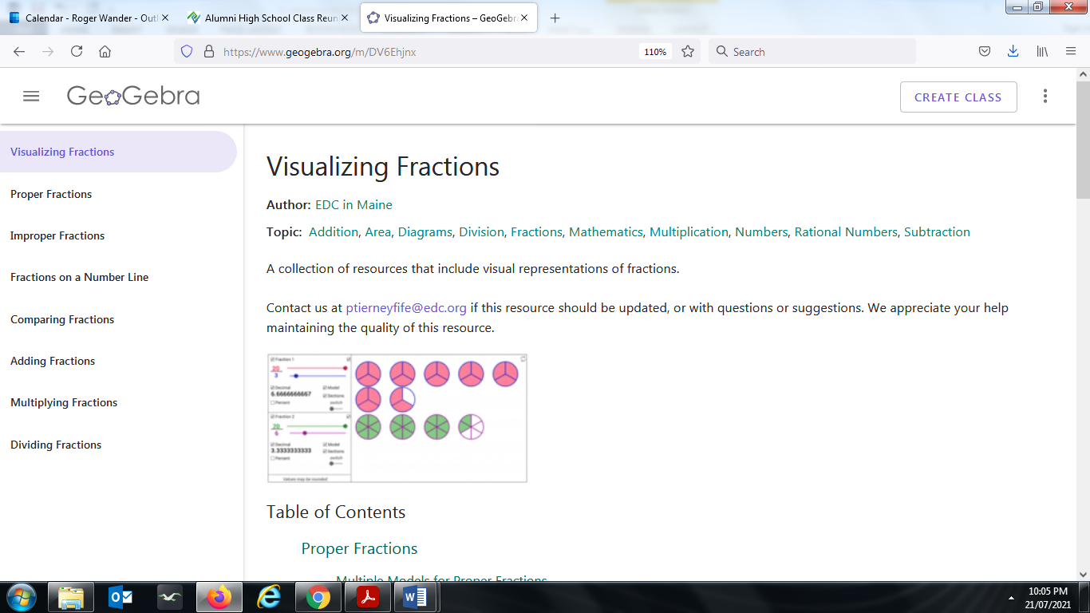 | https://www.geogebra.org/m/DV6Ehjnx  Superb!!  Treasure trove of GeoGebra-based fraction activities:  - Visualising fractions  - Proper fractions  - Improper fractions  - Fractions on a number line  - Comparing fractions  - Adding fractions  - Multiplying fractions  - Dividing fractions
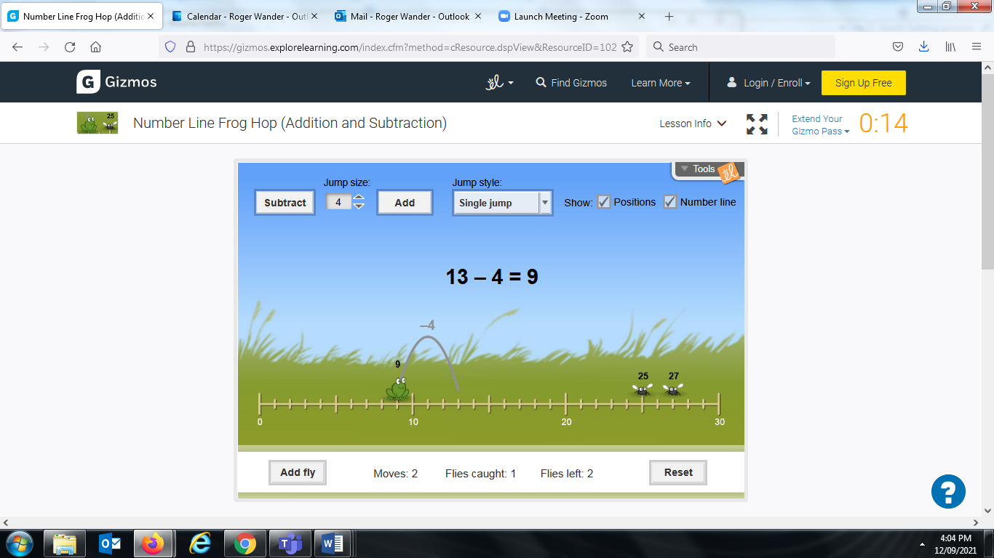 | Frog jumping along number line to catch flies. Visualise addition and subtraction using frog’s movement left or right on number line; this complements the more formal symbolic arithmetic.  As a guest, you only get 5 minutes per day.  https://gizmos.explorelearning.com/index.cfm?method=cResource.dspView&ResourceID=1022

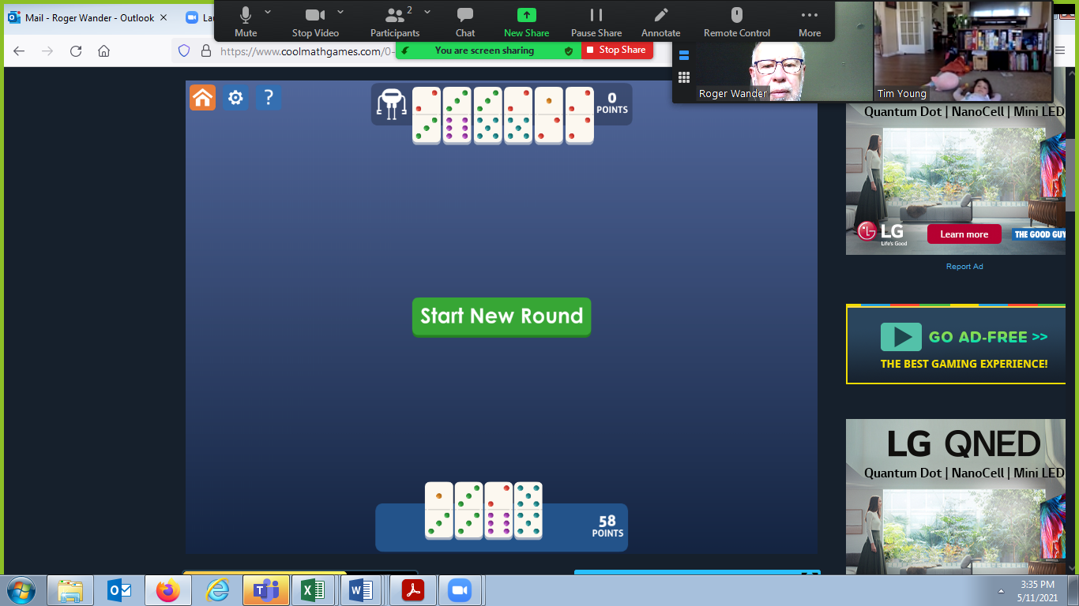 | Dominoes puzzle; can take a while to load up. Strategy, subitising.  https://www.coolmathgames.com/0-dominoes
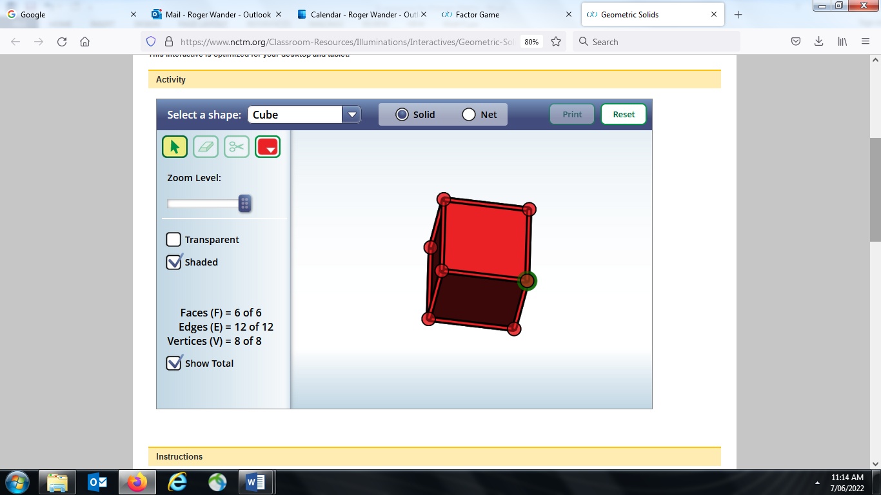 | Geometric Solids – excellent for development of maths vocabulary (faces, edges, vertices) and names of shapes. Can toggle between solid and net, also can create a net and “test” it. A very flexible app and easy to use – colouring is powerful tool enabling lots of challenges to be set e.g. colour this net so the opposite faces have the same colour. Another goodie from the NCTM.  https://www.nctm.org/Classroom-Resources/Illuminations/Interactives/Geometric-Solids/

Feel free to send me an email for e-versions of this document (enabling fast use of links for sites); and please let me know what you’ve found to be useful.
rdwander@unimelb.edu.au rogerdwander@gmail.com

